**2021.11.25 Lenses Experiment**

**Start Time:** circa 09.00



**Aim**

An experiment was carried out in order to study the imaging properties of lenses, through the concepts of geometrical optics. The practical consisted of imaging using a single lens to make predictions for perfect images, free from defects (such as chromatic or spherical aberration).

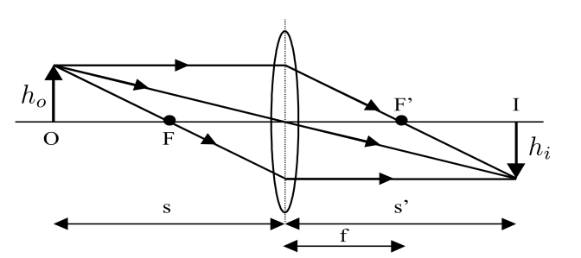

Figure 1: Lens of focal length f, forming image (I) and object (O)

s is the object distance, s’ is the image distance, hi is the image height

Source: Mangles et. al, 2021, “Year 1 Laboratory Manual: Lenses Experiment”, Imperial College

**Background**

Ray diagrams are schematics which are represent how lenses form an image. The line passing perpendicularly through the centre of the lens is known as the *‘principal axis’*, and these diagrams are constructed with the following three rules: incident rays travelling // to the principal axis refract through the lens, passing through F’ on the other side; incident rays travelling through the focal point on the way to the lens refract through passing parallel to the principal axis on the other side; any ray passing through the centre of the lens continues in the same direction.

For small angles, we can use the thin lens formula to obtain, for the object distance *s*, and image distance *s’*, that the following expression holds true:

$$\frac{1}{s} + \frac{1}{s'} = \frac{1}{f} (1)$$

with sign convention, that if light travels from left to right: s is positive (real) on the left, negative (virtual) on the right. For a converging lens, f > 0, whilst for a diverging lens, f < 0. In this sign convention, linear magnification M is defined as:

$$M = −\frac{s'}{s} = \frac{h_{i}}{h_{o}} (2)$$

where the negative sign indicates the formation of an inverted image. A single lens only provides high-quality images for small magnifications, so are typically used in combination with powerful imaging and magnification systems, such as compound microscopes as observed in Figure 2 below.

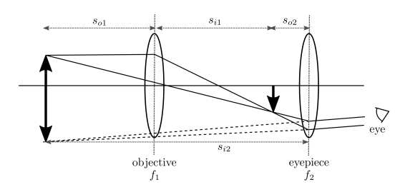

Figure 2: Compound microscope sketch which is composed of two lenses - the objective (f = f1, at distance so1 *and* so2, for the first and second lenses respectively), and eyepiece (f = f2,, at distance si1*and* si2).

Source: Mangles et. al, 2021, “Year 1 Laboratory Manual: Lenses Experiment”, Imperial College

The objective is placed at so1 > f1 away, and results in a real, enlarged image at si1. Consequently, the eyepiece acts as a magnifying glass inspecting the image at so2: the first lens’ image acts as the second lens’ object. The compound microscope’s total magnification, M, is given by:

$$M = M_{objective} · M_{eyepiece}= (\frac{{−s}_{i1}}{s_{o1}})·(\frac{{−s}_{i2}}{s_{o2}}) (3)$$

Experiment C examines a variation of the compound microscope allowing for a real image to be recorded by camera, rather than through observation of a virtual image through the naked eye, as is demonstrated in Figure 2 above. Whilst in previous experiments, we considered using the “thin lens” and small-angle ray approximations, for a real lens we require a more complete treatment by considering the physical optics (wave) picture - there are two crucial factors that result in image quality loss with real lenses - these are the finite diameter D of a lens, as well as aberrations in the lens, due to “details” of this real lens of notable thickness.

Light originating from a point source can be modelled as a spherical wave, and only part of this wave within the lens’ diameter contribute to the image - thus, the lens acts as a limiting circular aperture which diffracts light, besides imaging it. Consequently, A is not imaged to a point, but rather an “image spread function”, A’ . For perfect lenses without any abnormalities, we have a characteristic angular image size given by:

$$θ ≈ 1.22 · \frac{λ}{D} (4)$$

where 1.22 acts as a geometric factor taking into account the circular shape of the diffracting object. As a result, when two point objects subtend an angle such that α<θ, then they are merged together and unresolved as two separate objects. The point at which these two objects are said to just be resolved is when α = θ, and is known as the *Rayleigh Criterion*. The small-angle relationship α ≈ x/L can be used to find the minimum resolvable object size, x. Whilst the above (4), is known as the *diffraction-limited* resolution of a lens, in practice, due to aberrations in a lens that further degrade the image, there is usually a poorer resolution.

Using a resolution test based on the *three bar chart* slide, the resolution of the lens is given by the number of line pairs per mm in that element, lpairs*.* This is related to the smallest resolvable detail, x, by the relationship: $x = \frac{1}{2·l_{pairs}} (5)$. The chart is composed of a pattern split into groups with elements, of which there are six elements per group. Each element is composed for two target patterns, each consisting of three lines at right angles to each other, and with equal line-to-space ratio. The largest element in even-numbered groups are in the bottom-right corner, as opposed to with the other elements, and the pattern is repeated at an increasingly smaller scale towards the centre of the chart until group 7. Line pairs per mm are equal to 1 for the largest element in group 0, and increases by a factor of ⁶√2 every element. Consequently, the following table can be constructed to give line pairs per mm for the chart’s elements:

|  |  |  |  |  |
| --- | --- | --- | --- | --- |
| Element | 0 | 1 | 2 | 3 |
| 1  2  3  4  5  6 | 1.00  1.12  1.26  1.41  1.59  1.78 | 2.00  2.24  2.52  2.83  3.17  3.56 | 4.00  4.49  5.04  5.68  6.35  7.13 | 8.00  8.98  10.1  11.3  12.7  14.3 |

**Preliminary Questions**

From the lab manual:

Before you start your experiments do a couple of simple calculations, to help analyse what you might expect:

1. **Let x be the distance from the lens to the object, let d be the total distance between the object and the image. Substitute x and d into the lens formula and rearrange so that you have a quadratic equation of the form ax 2 + bx + c = 0. What are a, b and c in terms of d and f? Solve this equation for real roots of x.**

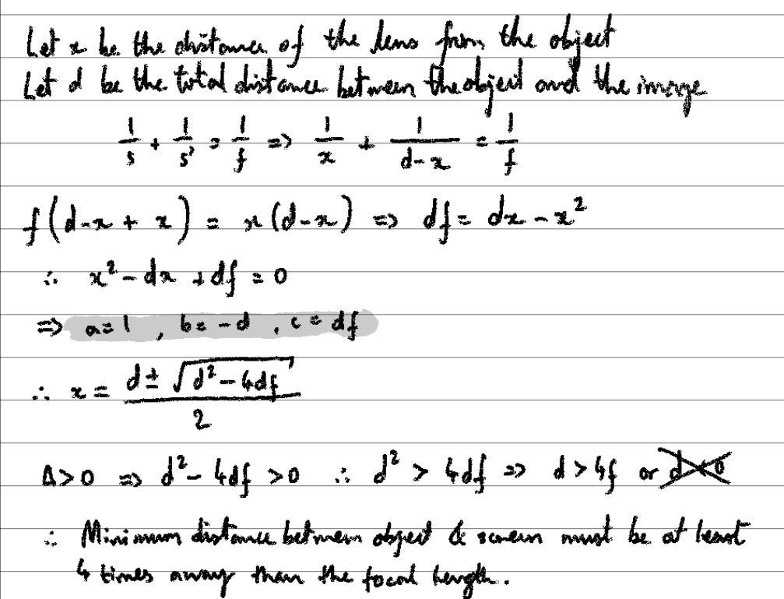

**Try to sketch a graph of x vs. d, where d is measured in units of f.**

One of my demonstrators, Isabel, told me that I probably should start taking readings instead of getting bogged down on drawing the diagram for the second part of question 1. As of now, I am still unsure as to how this graph would look.

1. **Using the definition for magnification M given above derive an expression for the object distance s in terms of the magnification and the focal length f. For a converging lens of focal length 100 mm where should you place the object if you want to produce a real image that is twice the size of the object (M = −2)? How far away from the lens will this image form?**

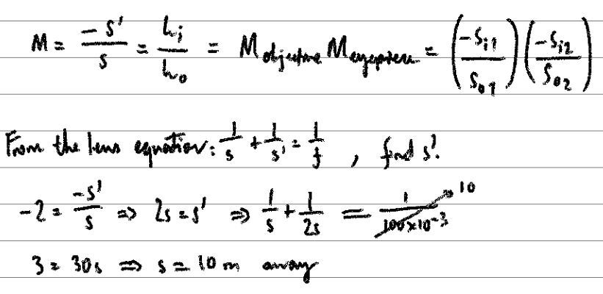

(?) probably incorrect, check later **

1. **If you put the object inside the focal length of a converging lens where does the image form? Draw a simple ray diagram based on figure 1.3.**

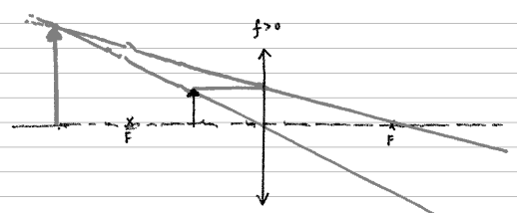

The image is virtual, upright, and magnified.

1. **Sketch the ray diagram of Figure 1.1 where the converging lens is replaced with a diverging lens (which has a negative focal length, f < 0).**

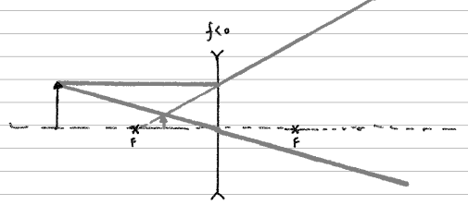

The image is virtual, upright, and diminished.

**Description of Set Up / Measurement Strategy**

The practical consisted of three experiments designed Experiment A - which tests the thin lens and magnification formulae, Experiment B - which makes observations on the formation of virtual images that can be observed as real images on a screen, and Experiment C - on the image resolution of a microscope.

In Experiment A, we wish to test the lens formula with the application of finding the focal length of the single lens used. This is conducted through measuring the object distance and image distance, plotting the reciprocals of each respectively against each other onto a graph, finding the y-intercept and therefore, by taking the reciprocal of this value, obtaining a calculation for the focal length. In addition to this, we wished to observe the trend between the magnification (M), and object distance (s).

Experiment A was set up as shown below:

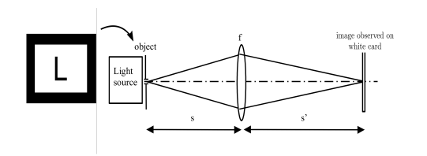

Figure 3: the experimental set-up for imaging with a lens f > 0

Source: Mangles et. al, 2021, “Year 1 Laboratory Manual: Lenses Experiment”, Imperial College

In Experiment B, we are concerned with virtual images, which cannot be observed without placing a screen where a clear, focused, real image can be seen. They are observed by looking through a lens, where the virtual image is formed. Experiment B was set-up as shown below. The light source was moved onto the optical rail, to allow for its position to be adjusted. The converging and diverging lens were similiar moved, as shown below (Fig. 4). The piece of white card was moved into place such that the image is focused. Both s’ and hi were recorded.

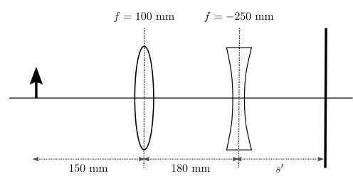

Figure 4: the arrangement for experiment B, with a compound lens arrangement

Source: Mangles et. al, 2021, “Year 1 Laboratory Manual: Lenses Experiment”, Imperial College

Following this, the diverging lens was removed from its holder, whilst keeping the converging lens and card fixed. Then the lamp was moved until the image is focused on the screen again, with new values of s and hi obtained.

The following ray diagram depicts the set-up for the first part of experiment B. The image is magnified, inverted, and real.

Following this, the biconcave lens is removed from the optical path, and the object is moved backwards until the image is once again crisp and focused. The above ray diagram depicts the second part of the experiment B. The image is magnified, inverted, and real.

In the final experiment, Experiment C, a real image was recorded using the CMOS camera, in an alternate version of the compound microscope set-up as shown in Figure 2. This experiment was carried out in order to test the imaging quality and resolving power of lenses, using a test based on the *three bar chart*.

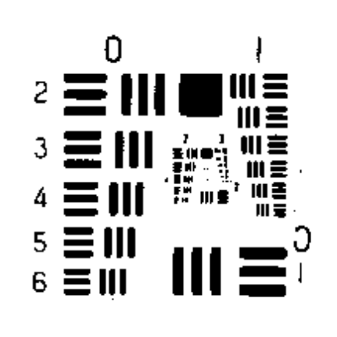

Figure 5: the arrangement of groups and elements on the three bar chart

Source: Mangles et. al, 2021, “Year 1 Laboratory Manual: Lenses Experiment”, Imperial College

In order to test the resolution of the human eye, a resolution chart was placed into the slide holder of the high source, and we sat in front of the light source, holding the slide approximately at 250mm, which is the near distance of the eye. The finest group that could be resolved was recorded, and the experiment was repeated for both in the lab pair. The result obtained was checked against (4), to see if they agree, by an estimate of the limiting diameter of the pupil, as well as the main wavelength of light.

Following this, the resolution of a microscope was tested by replacing the L slide in Figure 3 with the resolution slide - then, an image was taken using the CMOS camera. This result was also compared with (4).

**Preliminary Observations:**

From the lab manual:

Experiment A

**Set the distance between your lamp and the f = 100 mm lens to be s = 120 mm. Vary the position of the white card until you find the value of s ′ such that the image is focussed. What do you notice about the image? Is it larger or smaller? Is it inverted or the right-way up? Did you find it easy to find the exact location of the focal plane? Do you find you get different values**

What do you notice about the image?

Enlarged, inverted, real

Was it easy to find the exact location of the focal plane?

In order to reach the desired adjustment, it took 3 changes.

Do you find you get different values moving from far to near, and near to far?

It alternates between going out of focus and into focus.

Experiment B

**Draw the ray diagrams, and explain what is going on.**

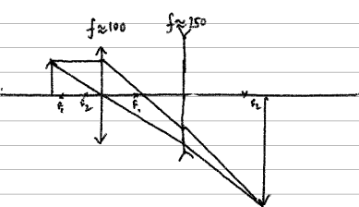

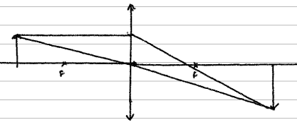

**Raw Data**

**Experiment A (equipment labeled as, f** ≈ **100mm**

The following data was synchronously recorded using Microsoft Excel.

|  |  |  |  |
| --- | --- | --- | --- |
| **Image Total Distance / m** | **Object Distance (s) / m** | **Image Height / m** | **Object Height / m** |
| 0.671 | 0.120 | 0.054 | 0.018 |
| 0.466 | 0.140 | 0.030 | 0.018 |
| 0.415 | 0.160 | 0.020 | 0.018 |
| 0.393 | 0.180 | 0.015 | 0.018 |
| 0.393 | 0.200 | 0.013 | 0.018 |
| 0.402 | 0.220 | 0.010 | 0.018 |
| 0.412 | 0.240 | 0.009 | 0.018 |
| 0.421 | 0.260 | 0.007 | 0.018 |
| 0.436 | 0.280 | 0.006 | 0.018 |
| 0.449 | 0.300 | 0.006 | 0.018 |
| 0.466 | 0.320 | 0.005 | 0.018 |
| 0.485 | 0.340 | 0.004 | 0.018 |
| 0.499 | 0.360 | 0.004 | 0.018 |
| 0.518 | 0.380 | 0.004 | 0.018 |
| 0.533 | 0.400 | 0.004 | 0.018 |
| 0.553 | 0.420 | 0.003 | 0.018 |
| 0.570 | 0.440 | 0.003 | 0.018 |
| 0.590 | 0.460 | 0.003 | 0.018 |
| 0.607 | 0.480 | 0.003 | 0.018 |
| 0.626 | 0.500 | 0.003 | 0.018 |
| 0.647 | 0.520 | 0.002 | 0.018 |

**Experiment B**

|  |  |  |  |
| --- | --- | --- | --- |
| **Image Distance / m** | **Image Height / m** |  | **f=100** |
| 0.220 | 0.045 | inverted, magnified, real |  |
| 0.134 | 0.036 | inverted, magnified, real |  |

**Experiment C**

Due to technical problems related to syncing and sync conflicts and the like, the measurements which were taken by myself for the testing of the resolution of the eye were erased (along with 3 out of 4 of my lab books (!) ) , and only some of the preliminary data remains from that purging.

Below, however, can be found my lab partner, Ollie’s data.

|  |  |  |  |
| --- | --- | --- | --- |
| 0.120 | m | Near Distance | 0.055 |
| 45.300 | lines per mm | | |
| 7.500 | mm | | |

Limiting diameter of the pupil was estimated to be 7.5mm, and as seen from the photograph on the right, the main wavelength was estimated to be roughly 580nm, as it was yellow predominantly.

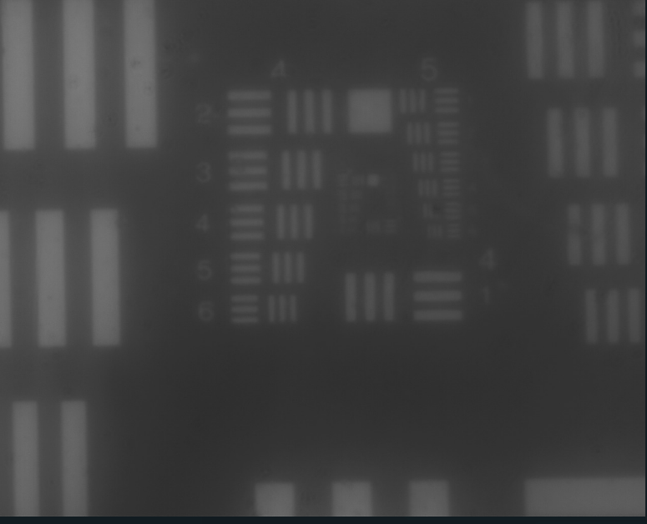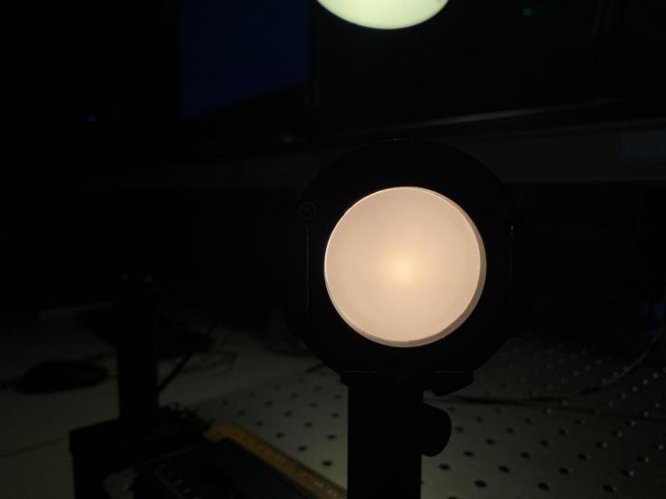

The smallest that could be resolved using the CMOS Camera was Group 5 Element 4, which corresponds to the following measurements:

|  |
| --- |
| Group 5 Element 4 |
| |  |  | | --- | --- | | 45.300 | lines per mm | |

**Data Analysis**

The following data analysis was carried out using Microsoft Excel and Python.

**Sources of Uncertainty**

**Experiment A**

|  |  |  |  |  |  |  |
| --- | --- | --- | --- | --- | --- | --- |
| ±0.001 | ±0.001 | ±0.002 | ±0.001 | ±0.001 |  | **f=100** |
| **Image Total Distance / m** | **Object Distance (s) / m** | **Image Actual Distance (s') / m** | **Image Height / m** | **Object Height / m** | **Image Distance ¯¹ / m¯¹** | **Object Distance ¯¹ / m¯¹** |
| 0.671 | 0.120 | 0.551 | 0.054 | 0.018 | 1.815 | 8.333 |
| 0.466 | 0.140 | 0.326 | 0.030 | 0.018 | 3.067 | 7.143 |
| 0.415 | 0.160 | 0.255 | 0.020 | 0.018 | 3.922 | 6.250 |
| 0.393 | 0.180 | 0.213 | 0.015 | 0.018 | 4.695 | 5.556 |
| 0.393 | 0.200 | 0.193 | 0.013 | 0.018 | 5.181 | 5.000 |
| 0.402 | 0.220 | 0.182 | 0.010 | 0.018 | 5.495 | 4.545 |
| 0.412 | 0.240 | 0.172 | 0.009 | 0.018 | 5.814 | 4.167 |
| 0.421 | 0.260 | 0.161 | 0.007 | 0.018 | 6.211 | 3.846 |
| 0.436 | 0.280 | 0.156 | 0.006 | 0.018 | 6.410 | 3.571 |
| 0.449 | 0.300 | 0.149 | 0.006 | 0.018 | 6.711 | 3.333 |
| 0.466 | 0.320 | 0.146 | 0.005 | 0.018 | 6.849 | 3.125 |
| 0.485 | 0.340 | 0.145 | 0.004 | 0.018 | 6.897 | 2.941 |
| 0.499 | 0.360 | 0.139 | 0.004 | 0.018 | 7.194 | 2.778 |
| 0.518 | 0.380 | 0.138 | 0.004 | 0.018 | 7.246 | 2.632 |
| 0.533 | 0.400 | 0.133 | 0.004 | 0.018 | 7.519 | 2.500 |
| 0.553 | 0.420 | 0.133 | 0.003 | 0.018 | 7.519 | 2.381 |
| 0.570 | 0.440 | 0.130 | 0.003 | 0.018 | 7.692 | 2.273 |
| 0.590 | 0.460 | 0.130 | 0.003 | 0.018 | 7.692 | 2.174 |
| 0.607 | 0.480 | 0.127 | 0.003 | 0.018 | 7.874 | 2.083 |
| 0.626 | 0.500 | 0.126 | 0.003 | 0.018 | 7.937 | 2.000 |
| 0.647 | 0.520 | 0.127 | 0.002 | 0.018 | 7.874 | 1.923 |

**Error Bars for Graphs**

|  |  |  |  |  |  |  |
| --- | --- | --- | --- | --- | --- | --- |
| **Error Bars** | ±0.001 |  |  |  |  |  |
| **Object Min** | **Object Max** | **1/s Min** | **1/s** | **1/s Max** | **1/s Error Below** | **1/s Error Above** |
| 0.119 | 0.121 | 8.264 | 8.333 | 8.403 | 0.069 | 0.070 |
| 0.139 | 0.141 | 7.092 | 7.143 | 7.194 | 0.051 | 0.051 |
| 0.159 | 0.161 | 6.211 | 6.250 | 6.289 | 0.039 | 0.039 |
| 0.179 | 0.181 | 5.525 | 5.556 | 5.587 | 0.031 | 0.031 |
| 0.199 | 0.201 | 4.975 | 5.000 | 5.025 | 0.025 | 0.025 |
| 0.219 | 0.221 | 4.525 | 4.545 | 4.566 | 0.021 | 0.021 |
| 0.239 | 0.241 | 4.149 | 4.167 | 4.184 | 0.017 | 0.017 |
| 0.259 | 0.261 | 3.831 | 3.846 | 3.861 | 0.015 | 0.015 |
| 0.279 | 0.281 | 3.559 | 3.571 | 3.584 | 0.013 | 0.013 |
| 0.299 | 0.301 | 3.322 | 3.333 | 3.344 | 0.011 | 0.011 |
| 0.319 | 0.321 | 3.115 | 3.125 | 3.135 | 0.010 | 0.010 |
| 0.339 | 0.341 | 2.933 | 2.941 | 2.950 | 0.009 | 0.009 |
| 0.359 | 0.361 | 2.770 | 2.778 | 2.786 | 0.008 | 0.008 |
| 0.379 | 0.381 | 2.625 | 2.632 | 2.639 | 0.007 | 0.007 |
| 0.399 | 0.401 | 2.494 | 2.500 | 2.506 | 0.006 | 0.006 |
| 0.419 | 0.421 | 2.375 | 2.381 | 2.387 | 0.006 | 0.006 |
| 0.439 | 0.441 | 2.268 | 2.273 | 2.278 | 0.005 | 0.005 |
| 0.459 | 0.461 | 2.169 | 2.174 | 2.179 | 0.005 | 0.005 |
| 0.479 | 0.481 | 2.079 | 2.083 | 2.088 | 0.004 | 0.004 |
| 0.499 | 0.501 | 1.996 | 2.000 | 2.004 | 0.004 | 0.004 |
| 0.519 | 0.521 | 1.919 | 1.923 | 1.927 | 0.004 | 0.004 |

|  |  |  |  |  |  |  |
| --- | --- | --- | --- | --- | --- | --- |
| ±0.001 |  |  |  |  |  |  |
| **Image Min** | **Image Max** | **1/s' Min** | **1/s'** | **1/s' Max** | **1/s' Error Below** | **1/s' Error Above** |
| 0.549 | 0.553 | 1.808 | 1.815 | 1.821 | 0.069 | 0.007 |
| 0.324 | 0.328 | 3.049 | 3.067 | 3.086 | 0.051 | 0.019 |
| 0.253 | 0.257 | 3.891 | 3.922 | 3.953 | 0.039 | 0.031 |
| 0.211 | 0.215 | 4.651 | 4.695 | 4.739 | 0.031 | 0.045 |
| 0.191 | 0.195 | 5.128 | 5.181 | 5.236 | 0.025 | 0.054 |
| 0.180 | 0.184 | 5.435 | 5.495 | 5.556 | 0.021 | 0.061 |
| 0.170 | 0.174 | 5.747 | 5.814 | 5.882 | 0.017 | 0.068 |
| 0.159 | 0.163 | 6.135 | 6.211 | 6.289 | 0.015 | 0.078 |
| 0.154 | 0.158 | 6.329 | 6.410 | 6.494 | 0.013 | 0.083 |
| 0.147 | 0.151 | 6.623 | 6.711 | 6.803 | 0.011 | 0.091 |
| 0.144 | 0.148 | 6.757 | 6.849 | 6.944 | 0.010 | 0.095 |
| 0.143 | 0.147 | 6.803 | 6.897 | 6.993 | 0.009 | 0.096 |
| 0.137 | 0.141 | 7.092 | 7.194 | 7.299 | 0.008 | 0.105 |
| 0.136 | 0.140 | 7.143 | 7.246 | 7.353 | 0.007 | 0.107 |
| 0.131 | 0.135 | 7.407 | 7.519 | 7.634 | 0.006 | 0.115 |
| 0.131 | 0.135 | 7.407 | 7.519 | 7.634 | 0.006 | 0.115 |
| 0.128 | 0.132 | 7.576 | 7.692 | 7.813 | 0.005 | 0.120 |
| 0.128 | 0.132 | 7.576 | 7.692 | 7.813 | 0.005 | 0.120 |
| 0.125 | 0.129 | 7.752 | 7.874 | 8.000 | 0.004 | 0.126 |
| 0.124 | 0.128 | 7.813 | 7.937 | 8.065 | 0.004 | 0.128 |
| 0.125 | 0.129 | 7.752 | 7.874 | 8.000 | 0.004 | 0.126 |

|  |  |  |  |  |  |  |  |  |
| --- | --- | --- | --- | --- | --- | --- | --- | --- |
| **M from Height Ratios** | **Hi Min** | **Hi Max** | **Ho Min** | **Ho Max** | **M min** | **M max** | **M Error Below** | **M Error Above** |
| 3.000 | 0.053 | 0.055 | 0.017 | 0.019 | 2.789 | 3.235 | 0.211 | 0.235 |
| 1.667 | 0.029 | 0.031 | 0.017 | 0.019 | 1.526 | 1.824 | 0.140 | 0.157 |
| 1.111 | 0.019 | 0.021 | 0.017 | 0.019 | 1.000 | 1.235 | 0.111 | 0.124 |
| 0.833 | 0.014 | 0.016 | 0.017 | 0.019 | 0.737 | 0.941 | 0.096 | 0.108 |
| 0.722 | 0.012 | 0.014 | 0.017 | 0.019 | 0.632 | 0.824 | 0.091 | 0.101 |
| 0.556 | 0.009 | 0.011 | 0.017 | 0.019 | 0.474 | 0.647 | 0.082 | 0.092 |
| 0.500 | 0.008 | 0.010 | 0.017 | 0.019 | 0.421 | 0.588 | 0.079 | 0.088 |
| 0.389 | 0.006 | 0.008 | 0.017 | 0.019 | 0.316 | 0.471 | 0.073 | 0.082 |
| 0.333 | 0.005 | 0.007 | 0.017 | 0.019 | 0.263 | 0.412 | 0.070 | 0.078 |
| 0.333 | 0.005 | 0.007 | 0.017 | 0.019 | 0.263 | 0.412 | 0.070 | 0.078 |
| 0.278 | 0.004 | 0.006 | 0.017 | 0.019 | 0.211 | 0.353 | 0.067 | 0.075 |
| 0.222 | 0.003 | 0.005 | 0.017 | 0.019 | 0.158 | 0.294 | 0.064 | 0.072 |
| 0.222 | 0.003 | 0.005 | 0.017 | 0.019 | 0.158 | 0.294 | 0.064 | 0.072 |
| 0.222 | 0.003 | 0.005 | 0.017 | 0.019 | 0.158 | 0.294 | 0.064 | 0.072 |
| 0.222 | 0.003 | 0.005 | 0.017 | 0.019 | 0.158 | 0.294 | 0.064 | 0.072 |
| 0.167 | 0.002 | 0.004 | 0.017 | 0.019 | 0.105 | 0.235 | 0.061 | 0.069 |
| 0.167 | 0.002 | 0.004 | 0.017 | 0.019 | 0.105 | 0.235 | 0.061 | 0.069 |
| 0.167 | 0.002 | 0.004 | 0.017 | 0.019 | 0.105 | 0.235 | 0.061 | 0.069 |
| 0.167 | 0.002 | 0.004 | 0.017 | 0.019 | 0.105 | 0.235 | 0.061 | 0.069 |
| 0.167 | 0.002 | 0.004 | 0.017 | 0.019 | 0.105 | 0.235 | 0.061 | 0.069 |
| 0.111 | 0.001 | 0.003 | 0.017 | 0.019 | 0.053 | 0.176 | 0.058 | 0.065 |

**Graphs**

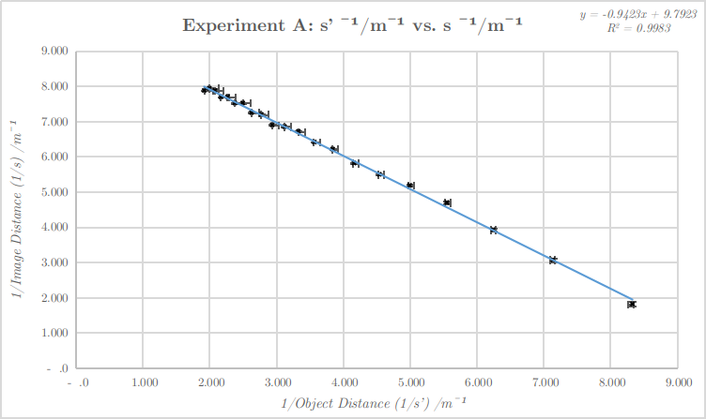

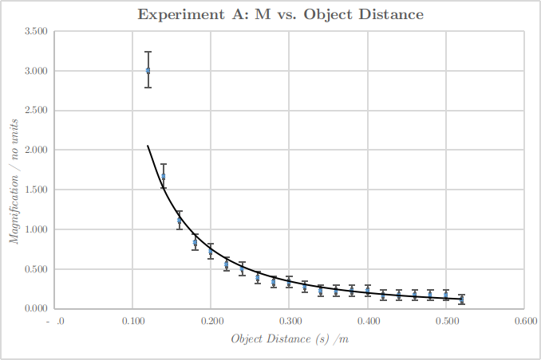

Graphs plotted with horizontal and vertical error bars, based on above calculations. The primary sources of uncertainty in experiment B came from the use of measuring apparatus, and the associated error that came from taking the reciprocal, which is expressed in the error bars for each point.

Using (1) rearranged, we subsequently can work out the value of the focal length:

**y-intercept:** 9.79±0.04

**focal length:** 0.102 +/- 0.009 m

**Experiment C**

The uncertainty for λ was estimated to be ±30nm based on the colour (yellow) of the light emitted. This, however, was insignificant compared to the massive uncertainty in the calculations involving the ruler.

|  |  |  |  |
| --- | --- | --- | --- |
| wavelength | 580 | ±30 | nm |
| Near Distance | 0.055 | m |  |

Using equation 4, i.e. the Rayleigh Criterion, we have that:

|  |  |  |  |
| --- | --- | --- | --- |
| x | 1.13E-05 | ±0.01 | m |

Using the data obtained from the CMOS camera, we have that using (5), that x = 1.104×10¯⁵ m, and are also both of the order 10¯⁵. Hence we can deduce that the resolution based from the eye was similar to that of the readings taken using the CMOS camera.

**Summary**

From the first graph in experiment A, we obtained a gradient and y-intercept using the built-in polyfit function of numpy. From there, we also obtained a covariance matrix from which we calculated uncertainties in each measurement. All in all, the focal length, f, came out to be f = (102 ± 9) mm which is in agreement with the value stated on the lens of f ≈ 100mm, and very clearly in the uncertainty range. As a result, I can deduce that the lens formula works fairly well in this situation.

From the second graph in experiment A, the maximum magnification appears to likely occur at approximately 0.10m, whilst the demagnification is at roughly 0.18m. It was noted that the magnification could be increased by using a lens of higher refractive index.

The values obtained in Experiment C were of the same order of magnitude. However, the first part of the experiment, involving an attempt to determine the resolution of the eye, was extremely qualitative, and involved a lot of uncertainty, therefore no conclusions could be reasonably drawn from it.